In 2001 I was working in Beijing and joined a group of 20 people on a mission to Qinghai in northern Tibet, to take school supplies and support the children of Tibet. The Swiss ambassador to China had acted as a go-between Tibet and China after the invasion. The Swissair station manager in Beijing, Marcus Shmidt and his wife Anne-Marie carried on the good work and led groups to visit the new schools and children. Our guide Kunga was a lama who represented the Dalai Lama in negotiations with the Chinese government.  
The peaceful buddhist country of Tibet was invaded by Communists China in 1949. Since that time, over 1.2 million out of 6 Tibetans have been killed, over 6000 monasteries have been destroyed, and thousands of Tibetans have been imprisoned. In Tibet today, there is no freedom of speech, religion, or press and arbitrary dissidents continue. The Dalai Lama, Tibet’s political and spiritual leader, fled to India in 1959. He now lives among over 100,000 other Tibetan refugees and their government in exile.

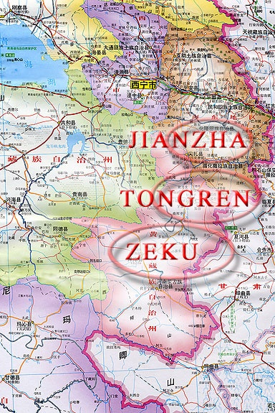

Most of the Tibetan plateau lies above 14,000 feet. Tibet is the source of five of Asia’s greatest rivers, which over 2 billion people depend upon. We visited the source of the great Yangtze river

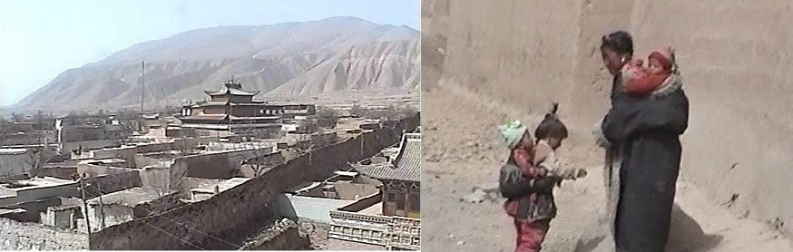

We flew from Beijing to Lanzhou in northern China. There we met Kunga and boarded a coach to drive to Tongren in Qinghai. Our journey was stopped by a landslide which required heavy machinery to clear the road. This was our first view of Tongren:

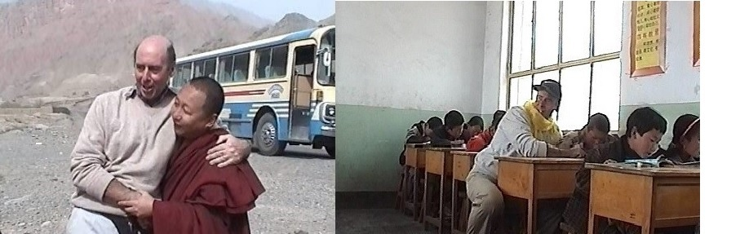

Over the next week we visited five schools built by Tibetans using materials paid for by Swiss doners. The children were taught the Tibetan language and traditions, despite being controlled by the Chinese. They were very healthy with lovely ruddy faces and I managed to play with a lot of them. At each stop we were presented with long silk scarves,

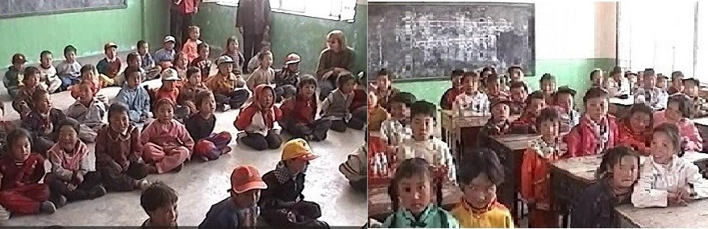

We visited Kunga’s monastery on a high mountain and were greeted like royalty. Some of our group had stayed there in order to meditate and help solve their problems. To get there we borrowed 4-wheel drive vehicles from the local police and fire brigade! At every main junction we spotted Chinese soldiers on motor bikes, keeping us under observation, probably because the Deputy Swiss Ambassador was part of our group.

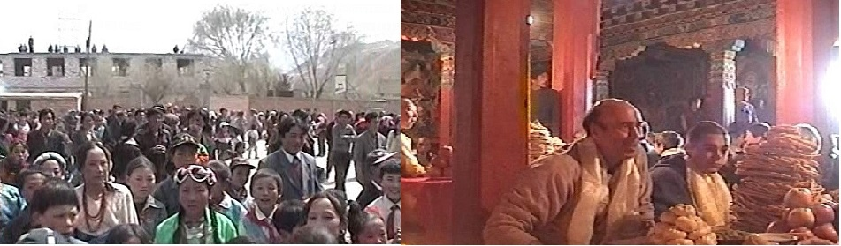

At the end of our tour we drove to a nearby town. The road was lined with cheering people waving as we passed. We attended a feast and a spectacular dancing display, with hundreds of people watching. Each of us was presented with a large circular loaf of bread weighing about 5kg! It was a wonderful gesture from such poor Tibetans. Kunga discretely ensured the bread was returned to the needy. I will never forget the beautiful Tibetan children.